Holy Name, Winfield and St. Mary Oxford
Mass Intentions Policy
The practice of requesting a Mass to be offered for loved ones, whether living or deceased, or for specific needs, is a beautiful and meaningful part of our Catholic tradition. To provide a fair opportunity for all parishioners to request Mass intentions, the following policies will take effect on August 1, 2026.

Scheduling and Date Availability
- You may only schedule a Mass 365 days beforehand (366 in a leap year) on a first-come-first serve basis. We cannot reserve an annual date for you. You must call each year to request the date.
  - If two or more people are asking for a specific date, and the date is of significant importance (day of death, an anniversary, etc.), and they call on the same day, that date's intentions will be honored on a rotating basis. In other words, one year it will be for Person A's intention and the next year it will be for Person B's intention.
- Multiple requests for the same intention will be spaced out, so as to allow for other intentions that month/year. This will be done at the parish staff's discretion and may occur on weekdays.
- If it is not practical for the priest to meet all the intentions within a calendar year, they must be sent elsewhere (Canon 956).
- The pastor is obligated under Canon 534 (Code of Canon Law) to offer a Mass for the People of the Parish each Sunday (or Saturday night) and on Solemnities, such as, but not limited to: December 8th: Immaculate COnception; January 1: Mary, the Holy Mother of God; March 19: Saint Joseph, Husband of Mary; March 25: The Annunciation of the Lord; June 24: Nativity of Saint John the Baptist; June 29: Saints Peter and Paul, Apostles; August 15: The Assumption of the Blessed Virgin, Mary; November 1: All Saints' Day (All Hallows'), Easter, the Ascension and Pentecost. No Mass intentions or limited Mass intentions will be available on those days.
- Every effort will be made to schedule the Mass as close as possible to the requested date and time.

When Someone Dies / Funeral Home Submissions
When someone dies, it is common to receive many intentions all at the same time. They will not all be scheduled immediately. They may be spaced out over the year or sent to the missions if they cannot be celebrated locally within the year. An effort will be made, when someone is newly deceased, to schedule a weekend Mass, for their soul, as soon as possible. A variety of people will ask for intentions for the same deceased person. We cannot schedule each requester's intention immediately. It is most important that the deceased be prayed for, not who is requesting the prayer.
Changes to the Mass Schedule
Occasionally, the Mass schedule may change due to priest illness, diocesan obligations, funerals, severe weather, or other unforeseen circumstances.
If a scheduled public Mass is canceled, the Mass intention will either be offered privately by the priest be rescheduled as soon as possible.

Announcement of Intentions
Priests are not required to announce the Mass intention aloud during the liturgy. Whether or not the intention is announced publicly, the graces of the Holy Mass are fully applied to the person or intention requested through the prayers of the priest and the celebration of the Eucharist.

Thank you for your understanding and cooperation as we strive to make Mass intention scheduling fair and accessible for all members of our parish community.
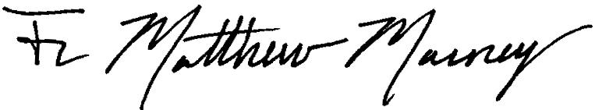
Pastor, Holy Name and St Mary’s

